***DMPM Assignment 2 Part 1***

Name: Rushikesh Jyoti

Division: A

Roll no: 27

SRN: 201901139

Question: Build a simple linear regression model using the given data-set

(a) Print model summary and (b) Plot residual plot (c) Plot scatter plot showing the fitted line.

Perform this for 2 cases as below

Case 1: response = Wt and predictor = Ht

Case 2: response = Wt and predictor = Age

***Code***

df = read.csv("HT-WT-Age.csv")[2:4]

head(df)

summary(df)

model1 = lm(df$Weight ~ df$Height)

model1

pred1 = predict(model1)

resd1 = residuals(model1)

summary(model1)

plot(df$Weight, df$Height,

main = "Height and Weight",

abline(lm(df$Height ~ df$Weight)),

ylab = "Height in cm",

xlab = "Weight in kg"

)

plot(df$Height, resd1,

main = "Residual Plot(HT and WT)",

abline(0,0),

ylab = "Residuals",

xlab = "Height in cm"

)

model2 <- lm(df$Weight ~ df$Age)

print(model2)

print(summary(model2))

pred2 <- predict(model2)

resd2 <- residuals(model2)

print(pred2)

print(resd2)

plot(df$Weight,

df$Age,

main = "Age and Weight",

abline(lm(df$Age~df$Weight)),

ylab = "Age in years",

xlab = "Weight in kg"

)

plot(df$Age,

resd2,

main = "Residual Plot(Age and WT)",

abline(0,0),

ylab = "Residuals",

xlab = "Age in years"

)

***Output***

1. Summary

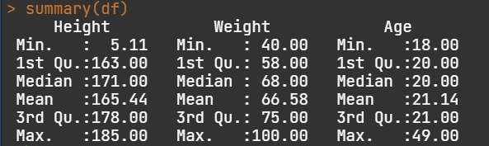

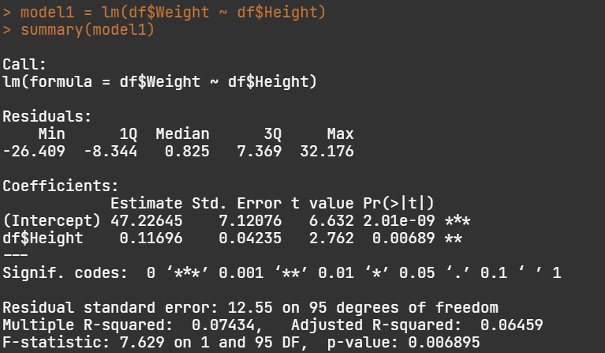

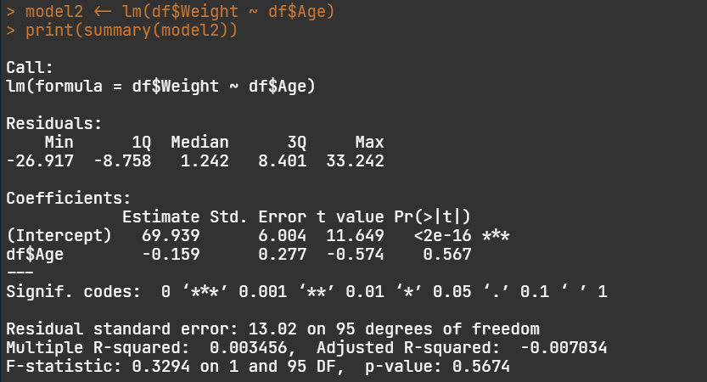

1. Residual Plot

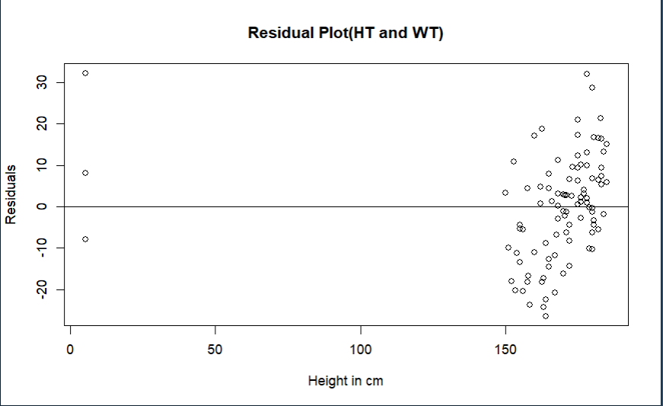

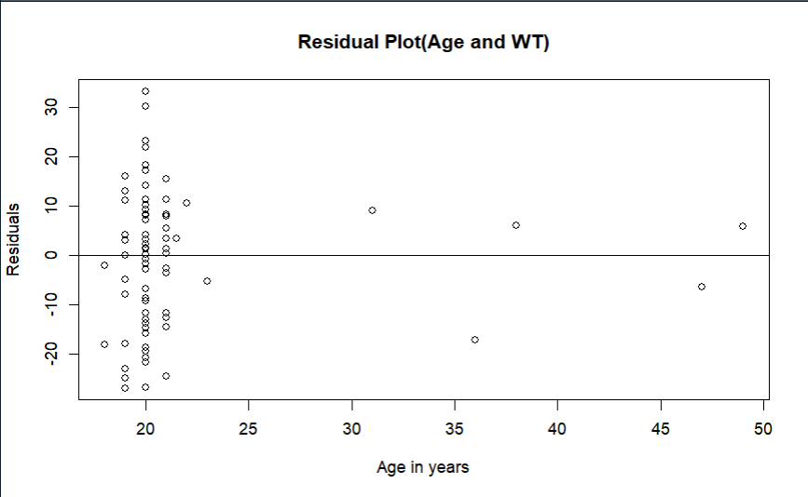

1. Scatter Plot